Launcher WebPage – Index.php

//Checks status of servers. Also contains which ports we will need to forward for the game.

/\* Статус серверов \*/

$ApiStatus = @fsockopen ("25.169.242.158","80",$errno, $errstr, 1);

$LoginStatus = @fsockopen ("25.169.242.158","39190",$errno, $errstr, 1);

$GameStatus = @fsockopen ("25.169.242.158","39191",$errno, $errstr, 1);

$BattleStatus = @fsockopen ("25.169.242.158","40000",$errno, $errstr, 1);

Found the main loader. We will need to package together the Loader and the game itself into one location. Uses the StartupPath for this loader to find the PointBlank.exe. //Main.cs – Solution Launcher

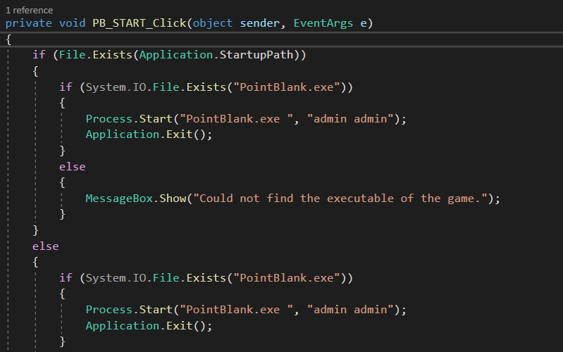

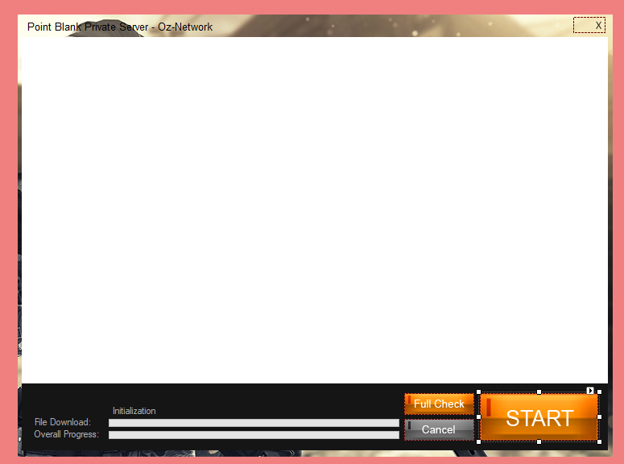

s